Dear Parent, Caregiver, Teacher, and Administrator,

Your school has provided you with a subscription to ReadyRosie.

ReadyRosie is an online resource that provides DAILY activities for adults to do with children ages zero to four. The activities are simple and take only about two minutes a day!

Each activity is modeled on a two minute video. Simply watch the video, do the activity, and everyone learns something new!

Upon registration, you will begin receiving an email each weekday with an activity you can do at home or at school with your child(ren). Each email will contain:

- An activity modeled on video in ENGLISH
- A similar activity modeled on video in SPANISH
- An expert video that helps explain the WHY behind the activity

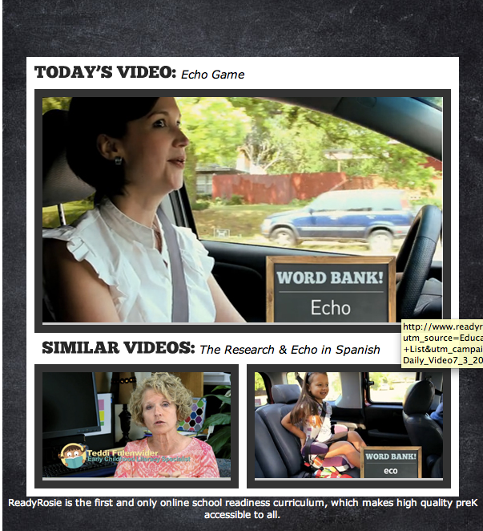

Register today to begin receiving this exciting new resource!
www.readyrosie.com/signup

Thank you and enjoy!

